Wireframe

Flight Fare Prediction

Revision Number - 1.3

Last Date of Revision: 21-01-2024

Yash Dabke

Document Version Control

|  |  |  |  |
| --- | --- | --- | --- |
| **Date** | **Version** | **Description** | **Author** |
| 18-01-2024 | 1.0 | Abstract Introduction Architecture | Yash Dabke |
| 19-01-2024 | 1.1 | Architectural Design | Yash Dabke |
| 19-01-2024 | 1.2 | Deployment Unit Test Cases | Yash Dabke |
| 20-01-2024 | 1.3 | Finalization | Yash Dabke |

Contents

Document Version Control **………………………………………………………............................2**

Abstract **………………………………………………………............................................................4**

Web Interface **………………………………………………………..................................................5**

1.1 Landing Page **………………………………………………………...........................................5**

1.2 Predictor Page **………………………………………………………..........................................6**

1.3 About Us Page **………………………………………………………..........................................7**

• User Input **………………………………………………………......................................................9**

• Result Page **………………………………………………………………………………………..10**

Abstract

The recent changes in the international market had a large impact on the Aviation sector because of several reasons. These impact the two class folks, the first is Business perspective and second is Customer perspective. The major reason for such impact is the governments around the world amended totally different rules to their various Airline firms. Taking these factors into consideration, the value of the flight tickets has varied from one place to another. Booking a flight ticket has its price tag split into two, one is online bookings and other is offline bookings. Each of these have their various criteria for value of the price, one such example is the server load and therefore the range of booking requests. During this machine learning implementation, we are going to see numerous factors that impact the price of the flight ticket and predict the acceptable price of the ticket.

Web Interface

1.1 Landing Page

When the user lands on our webpage, they will be greeted with a warm welcome to the Flight Fare Prediction System, an innovative solution designed to help them find the best flight deals. Our user-friendly interface provides a seamless experience, allowing travellers to predict flight ticket prices for various routes and airlines accurately.

At the heart of our system lies a powerful machine learning model that has been meticulously trained on a diverse dataset of flight information. By harnessing the potential of cutting-edge technologies and data science techniques, we can deliver reliable and precise predictions to assist users in making informed decisions while planning their travel.

Navigating through the landing page, users will find an intuitive interface that encourages easy interaction. With straightforward instructions and clear visuals, users can effortlessly input their travel details, such as date of journey, departure time, arrival time, preferred airlines, source, and destination.

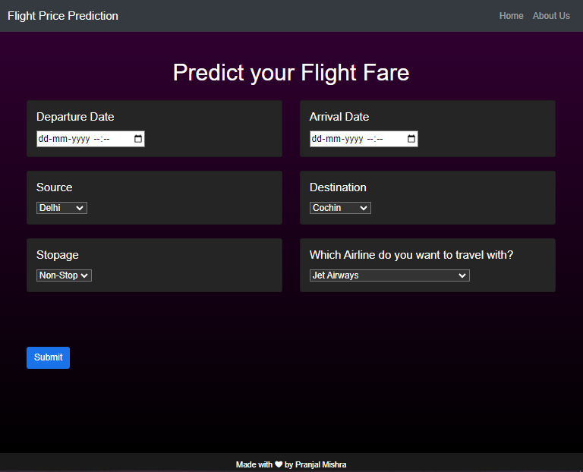

1.2 Predictor Page

The user sees various fields asking for information that is required to predict the price of a flight. Every user input has its dropdown where the user can select their input. After providing the required When the user lands on our webpage, they will be greeted with a warm welcome to the Flight Fare Prediction System, an innovative solution designed to help them find the best flight deals. Our user-friendly interface provides a seamless experience, allowing travellers to predict flight ticket prices for various routes and airlines accurately.

At the heart of our system lies a powerful machine learning model that has been meticulously trained on a diverse dataset of flight information. By harnessing the potential of cutting-edge technologies and data science techniques, we can deliver reliable and precise predictions to assist users in making informed decisions while planning their travel.

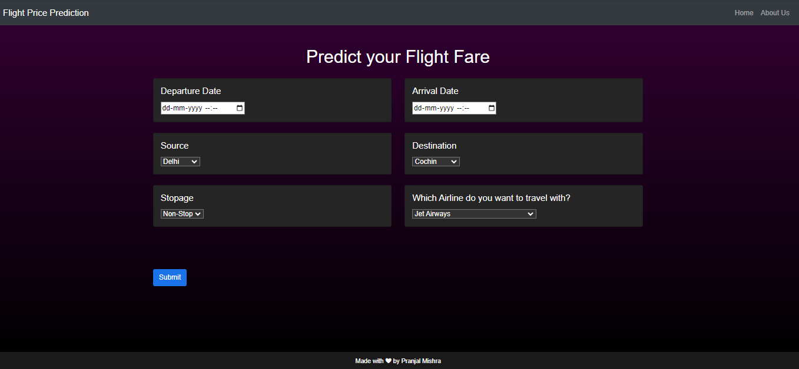

1.3 About Us Page

The About Us page showcases a comprehensive and engaging summary of the brilliant individuals who have poured their dedication, expertise, and passion into bringing this remarkable Flight Fare Prediction System to life. As the sole creator and developer of this project, I take immense pride in sharing the story of how this innovative platform came into existence.

Our journey:

The journey began with a vision to revolutionize the travel industry and empower travellers with the ability to predict flight prices accurately. From the initial concept to the final execution, every step was meticulously planned and executed to perfection.

Meet the Creator:

As the sole architect of this web application, I have invested countless hours of hard work and sleepless nights to design, develop, and implement every aspect of the Flight Fare Prediction System. My passion for data science, machine learning, and web development has been the driving force behind this endeavor.

Passion for Excellence:

The commitment to delivering excellence is at the core of this project. From selecting the most relevant features to curating a diverse dataset, and from training the machine learning model to building the user-friendly interface, every detail has been crafted with precision and care.

Social Links and Collaboration:

In addition to sharing our team's brief background, the About Us page also provides direct links to our social media profiles. These links serve as an open invitation for collaboration and networking with like-minded individuals in the data science and tech community.

Our Promise:

As the sole creator of this project, I take personal responsibility for its functionality, reliability, and continuous improvement. The Flight Fare Prediction System will be actively maintained, and any feedback or suggestions from users will be highly valued and promptly considered for enhancement.

The About Us page is a testament to the commitment, determination, and skill that went into creating this Flight Fare Prediction System. It reflects the unwavering dedication of a passionate individual, striving to create a lasting impact in the world of data science and travel technology. Thank you for being a part of this incredible journey.

User Input

On the predictor page, the user has to provide all the information asked for the prediction. The user can select from the drop-down lists attached to each of the input fields. Once all the asked information is provided, the user clicks on the submit button to get the output.

1. Departure Date and Time:

Select the date and time of your flight's departure from the user-friendly calendar and time picker. Ensure accurate input to get the best prediction.

2. Arrival Date and Time:

Next, choose the date and time of your flight's arrival at the destination. This crucial information aids in predicting the flight fare with precision.

3. Departure Source:

From the drop-down list, select the source or origin of your flight. This could be the city or airport from where you'll be departing.

4. Destination:

Similarly, choose your flight's destination from the drop-down list. Indicate the city or airport where you'll be arriving.

5. Number of Stopovers:

Select the number of stopovers or layovers you are willing to make during your journey. This helps tailor the prediction to your travel preferences.

6. Preferred Airline:

Pick your preferred airline from the drop-down list. If you have a specific airline in mind, we can consider its pricing policies for the prediction.

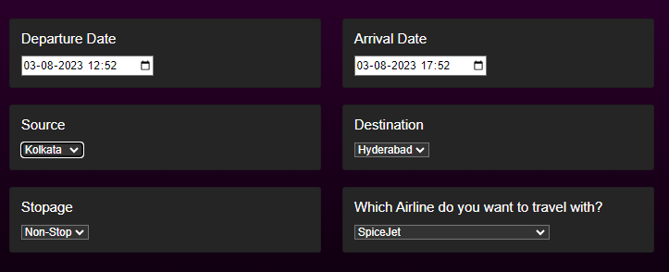

Results Page

On the predictor page, the user provides all the asked information and then clicks on the submit button. The predicted fare of the selected flight is displayed to the user on the same vary page below the Submit button.

Below the "Submit" button, you'll find the predicted fare for the flight based on the details you provided. Our advanced machine learning algorithm has processed your input and calculated the estimated cost for your journey.

Ex:

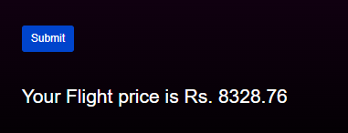

Deployed WebApp:   
**Here’s the link to the Flight Price Prediction Project** https://github.com/yashdabke/Flight-Fare-Prediction